Cloud Setup:
https://github.com/yasapurnama/Install-Kubernetes-with-AWS-Cloud-Provider
Use the above repo to setup the environment until “Worker Node”
On Master Node:
--
TOKEN=`curl -X PUT "http://169.254.169.254/latest/api/token" -H "X-aws-ec2-metadata-token-ttl-seconds: 21600"`
--

--
hostnamectl set-hostname $(curl -s http://169.254.169.254/latest/meta-data/local-hostname -H "X-aws-ec2-metadata-token: $TOKEN")

--
#create a sh file (container.sh)
#!/bin/bash

sudo apt update

sudo swapoff -a

sudo sed -i '/ swap / s/^\(.*\)$/#\1/g' /etc/fstab

sudo tee /etc/modules-load.d/containerd.conf <<EOF
overlay
br_netfilter
EOF

sudo modprobe overlay
sudo modprobe br_netfilter

sudo tee /etc/sysctl.d/kubernetes.conf <<EOF
net.bridge.bridge-nf-call-ip6tables = 1
net.bridge.bridge-nf-call-iptables = 1
net.ipv4.ip_forward = 1
EOF
sudo sysctl --system

sudo apt install -y ca-certificates curl gnupg lsb-release

sudo mkdir -p /etc/apt/keyrings

curl -fsSL https://download.docker.com/linux/ubuntu/gpg | sudo gpg --dearmor -o /etc/apt/keyrings/docker.gpg

echo "deb [arch=$(dpkg --print-architecture) signed-by=/etc/apt/keyrings/docker.gpg] https://download.docker.com/linux/ubuntu $(lsb_release -cs) stable" | sudo tee /etc/apt/sources.list.d/docker.list > /dev/null

sudo apt update

sudo apt install -y containerd.io

containerd config default | sudo tee /etc/containerd/config.toml >/dev/null 2>&1
sudo sed -i 's/SystemdCgroup \= false/SystemdCgroup \= true/g' /etc/containerd/config.toml
sudo systemctl restart containerd
sudo systemctl enable containerd

# execute the above file (bash container.sh)

#create a new script file for installation(kube.sh)
#!/bin/bash

sudo apt-get update

sudo apt-get install -y apt-transport-https ca-certificates curl gpg
curl -fsSL https://pkgs.k8s.io/core:/stable:/v1.28/deb/Release.key | sudo gpg --dearmor -o /etc/apt/keyrings/kubernetes-apt-keyring.gpg
echo 'deb [signed-by=/etc/apt/keyrings/kubernetes-apt-keyring.gpg] https://pkgs.k8s.io/core:/stable:/v1.28/deb/ /' | sudo tee /etc/apt/sources.list.d/kubernetes.list
sudo apt-get update
sudo apt-get install -y kubelet=1.28.* kubeadm=1.28.* kubectl=1.28.*
sudo apt-mark hold kubelet kubeadm kubectl
sudo systemctl enable --now kubelet

# execute the above file (bash kube.sh)

Create an yaml file
vi /etc/kubernetes/aws.yml
---
apiVersion: kubeadm.k8s.io/v1beta3
kind: ClusterConfiguration
apiServer:
extraArgs:
cloud-provider: external
controllerManager:
extraArgs:
cloud-provider: external
kubernetesVersion: v1.28.15
networking:
podSubnet: 192.168.0.0/16
serviceSubnet: 10.96.0.0/12
---
apiVersion: kubeadm.k8s.io/v1beta3
kind: InitConfiguration
nodeRegistration:
kubeletExtraArgs:
cloud-provider: external

kubeadm init --config /etc/kubernetes/aws.yml
Note: once we execute the above command, we will receive the join command, copy and save it
(kubeadm join 10.0.0.7:6443 --token dm06dh.50geayt0lp6k9tuu \
--discovery-token-ca-cert-hash sha256:c3c26ca820349eaa8deb834d5ced5d7d3850bad692c3b82735b3e507db17961b)
mkdir -p $HOME/.kube
sudo cp -i /etc/kubernetes/admin.conf $HOME/.kube/config
sudo chown $(id -u):$(id -g) $HOME/.kube/config
export KUBECONFIG=/etc/kubernetes/admin.conf
--
kubectl apply -k 'github.com/kubernetes/cloud-provider-aws/examples/existing-cluster/base/?ref=master'
--
kubectl get pods -A
kubectl apply -f https://docs.projectcalico.org/manifests/calico.yaml
kubectl get pods -A
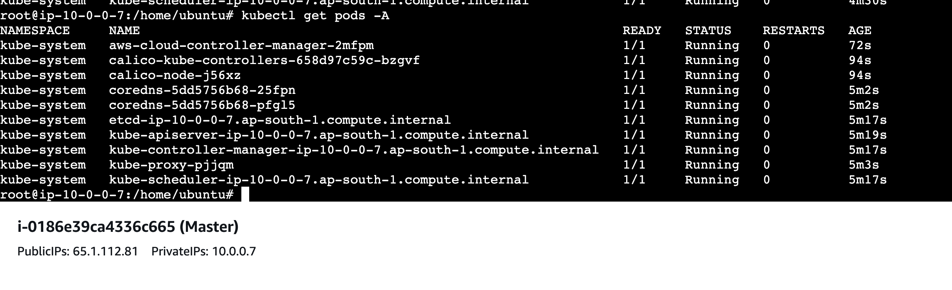

On Worker Node:
--
TOKEN=`curl -X PUT "http://169.254.169.254/latest/api/token" -H "X-aws-ec2-metadata-token-ttl-seconds: 21600"`
--

--
hostnamectl set-hostname $(curl -s http://169.254.169.254/latest/meta-data/local-hostname -H "X-aws-ec2-metadata-token: $TOKEN")

--
#create a sh file (container.sh)
#!/bin/bash

sudo apt update

sudo swapoff -a

sudo sed -i '/ swap / s/^\(.*\)$/#\1/g' /etc/fstab

sudo tee /etc/modules-load.d/containerd.conf <<EOF
overlay
br_netfilter
EOF

sudo modprobe overlay
sudo modprobe br_netfilter

sudo tee /etc/sysctl.d/kubernetes.conf <<EOF
net.bridge.bridge-nf-call-ip6tables = 1
net.bridge.bridge-nf-call-iptables = 1
net.ipv4.ip_forward = 1
EOF
sudo sysctl --system

sudo apt install -y ca-certificates curl gnupg lsb-release

sudo mkdir -p /etc/apt/keyrings

curl -fsSL https://download.docker.com/linux/ubuntu/gpg | sudo gpg --dearmor -o /etc/apt/keyrings/docker.gpg

echo "deb [arch=$(dpkg --print-architecture) signed-by=/etc/apt/keyrings/docker.gpg] https://download.docker.com/linux/ubuntu $(lsb_release -cs) stable" | sudo tee /etc/apt/sources.list.d/docker.list > /dev/null

sudo apt update

sudo apt install -y containerd.io

containerd config default | sudo tee /etc/containerd/config.toml >/dev/null 2>&1
sudo sed -i 's/SystemdCgroup \= false/SystemdCgroup \= true/g' /etc/containerd/config.toml
sudo systemctl restart containerd
sudo systemctl enable containerd

# execute the above file (bash container.sh)

#create a new script file for installation(kube.sh)
#!/bin/bash

sudo apt-get update

sudo apt-get install -y apt-transport-https ca-certificates curl gpg
curl -fsSL https://pkgs.k8s.io/core:/stable:/v1.28/deb/Release.key | sudo gpg --dearmor -o /etc/apt/keyrings/kubernetes-apt-keyring.gpg
echo 'deb [signed-by=/etc/apt/keyrings/kubernetes-apt-keyring.gpg] https://pkgs.k8s.io/core:/stable:/v1.28/deb/ /' | sudo tee /etc/apt/sources.list.d/kubernetes.list
sudo apt-get update
sudo apt-get install -y kubelet=1.28.* kubeadm=1.28.* kubectl=1.28.*
sudo apt-mark hold kubelet kubeadm kubectl
sudo systemctl enable --now kubelet

# execute the above file (bash kube.sh)

hostname -f
- This will return the hostname
Let’s update the content of the below yaml file, replace the below values ‘token’,’ apiServerEndpoint’,’sha’, and ‘name’. We will get these values from the join command which we got on the master node expect name. The value for the name will be the output of hostname -f command
apiVersion: kubeadm.k8s.io/v1beta3
kind: JoinConfiguration
discovery:
bootstrapToken:
token: "dm06dh.50geayt0lp6k9tuu"
apiServerEndpoint: "10.0.0.7:6443"
caCertHashes:
- "sha256:c3c26ca820349eaa8deb834d5ced5d7d3850bad692c3b82735b3e507db17961b"
nodeRegistration:
name: ip-10-0-0-205.ap-south-1.compute.internal
kubeletExtraArgs:
cloud-provider: external
EOF

Run the below command
cat << EOF > /etc/kubernetes/node.yml
---
apiVersion: kubeadm.k8s.io/v1beta3
kind: JoinConfiguration
discovery:
bootstrapToken:
token: "dm06dh.50geayt0lp6k9tuu"
apiServerEndpoint: "10.0.0.7:6443"
caCertHashes:
- "sha256:c3c26ca820349eaa8deb834d5ced5d7d3850bad692c3b82735b3e507db17961b"
nodeRegistration:
name: ip-10-0-0-205.ap-south-1.compute.internal
kubeletExtraArgs:
cloud-provider: external
EOF

kubeadm join --config /etc/kubernetes/node.yml

On master:
Kubectl get nodes
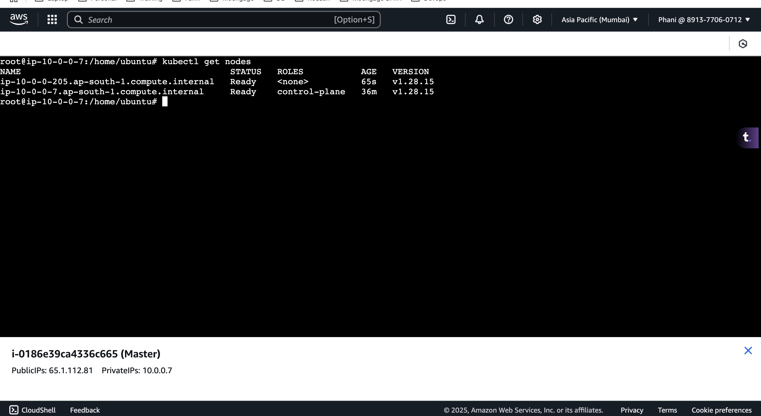

Goto aws roles
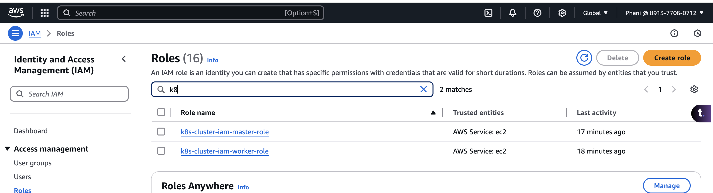
On master role, click on attach policies and add the below policies
AmazonEC2FullAccess
AdministratorAccess
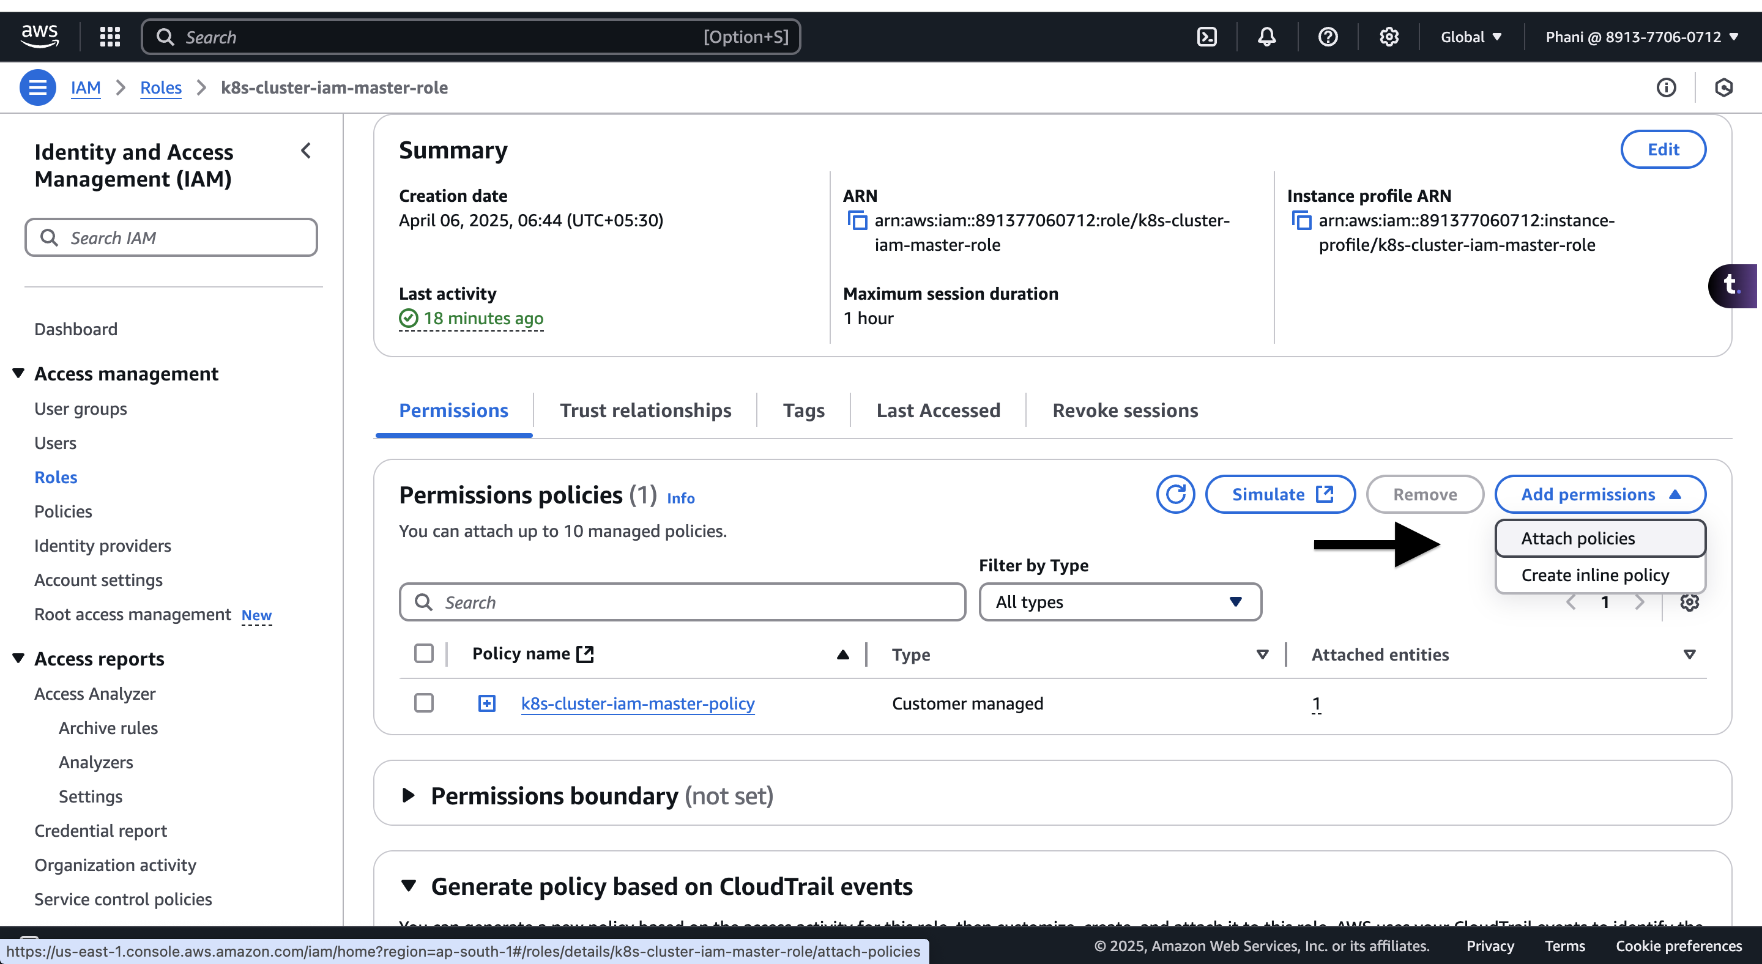

Perform the same steps on the worker role as well.
